Batch: C3 Roll No.: 16010123217

Experiment No. 05

Grade: AA / AB / BB / BC / CC / CD /DD

Signature of the Staff In-charge with date

TITLE: Implementation of Priority Based CPU Scheduling Algorithms – Pre-emptive and Non Pre-emptive.
_____________________________________________________________________

AIM: Implementation of Priority Based CPU Scheduling Algorithms – Pre-emptive Non Preemptive
______________________________________________________________________
Expected Outcome of Experiment:

CO 2 Illustrate and analyse the Process, threads, process scheduling and thread scheduling _____________________________________________________________________
Books/ Journals/ Websites referred:

- Silberschatz A., Galvin P., Gagne G. “Operating Systems Principles”, Willey Eight edition.
- Achyut S. Godbole , Atul Kahate “Operating Systems” McGraw Hill Third Edition.
- William Stallings, “Operating System Internal & Design Principles”, Pearson.
- Andrew S. Tanenbaum, “Modern Operating System”, Prentice Hall.
_____________________________________________________________________
Pre Lab/ Prior Concepts:
Priority scheduling in OS is the scheduling algorithm that schedules processes according to the priority assigned to each of the processes. Higher priority processes are executed before lower priority processes.
What is a Priority Scheduling Algorithm?
The Operating System has a major function of deciding the order in which processes/tasks will have access to the processor and the amount of processing time each of these processes or tasks will have. This function of the operating system is termed process scheduling.
Under process scheduling, the tasks that the operating system performs are:
- Keeping track of the status of the processes
- Allocation of processor to processes
- De-allocation of the processor to processes.
All these processes are stored by the operating system in a process table along with an ID allotted to every process (PID), to help keep track of all of them. And, to keep track of their current state the operating system uses a Process Control Block (PCB). The information is updated in the control block as and when the state of the process changes.
But did you wonder what is the criteria that the Operating System uses for the scheduling of these processes? Which process must be allocated with CPU resources first?
Well, there are multiple ways in which the Operating System makes these decisions such as execution of the process that takes the least time first, or execution according to the order in which they requested access to the processor, and so on. One such important criterion is the priority of the process.
In priority scheduling in OS, processes are executed on the basis of their priority. The jobs/processes with higher priority are executed first. Naturally, you might want to know how the priority of processes is decided.
Priority of processes depends on some factors such as:
Time limit
Memory requirements of the process
Ratio of average I/O to average CPU burst time
There can be more factors on the basis of which the priority of a process/job is determined. This priority is assigned to the processes by the scheduler.
These priorities of processes are represented as simple integers in a fixed range such as 0 to 7, or maybe 0 to 4095. These numbers depend on the type of system.
Now that we know that each job is assigned a priority on the basis of which it is scheduled, we can move ahead with its working and types.

Types of Priority Scheduling Algorithms
There are two types of priority scheduling algorithms in OS:
Non-Preemptive Scheduling
In this type of scheduling:
If during the execution of a process, another process with a higher priority arrives for execution, even then the currently executing process will not be disturbed.
The newly arrived high priority process will be put in next for execution since it has higher priority than the processes that are in a waiting state for execution.
All the other processes will remain in the waiting queue to be processed. Once the execution of the current process is done, the high-priority process will be given the CPU for execution.
Preemptive Scheduling
`Preemptive Scheduling as opposed to non-preemptive scheduling will preempt (stop and store the currently executing process) the currently running process if a higher priority process enters the waiting state for execution and will execute the higher priority process first and then resume executing the previous process.
Characteristics of Priority Scheduling Algorithm
It is a scheduling algorithm that schedules the incoming processes on the basis of priority.
Operating systems use it for performing batch processes
If there exist two jobs/processes in the ready state (ready for execution) that have the same priority, then priority scheduling executes the processes on a first come first serve basis. For every job that exists, we have a priority number assigned to it that indicates its priority level.
If the integer value of the priority number is low, it means that the process has a higher priority. (low number = high priority).

Description of the application to be implemented:
Pre-emptive :
#include <bits/stdc++.h>
using namespace std;

int main() {
cout << "Enter the number of processes: ";
int n;
cin >> n;

vector<pair<int, pair<pair<int, int>, string>>> v1(n);
vector<int> remaining_bt(n);

cout << "Enter Process ID, Priority, Arrival Time, Burst Time for each process:\n";
for (int i = 0; i < n; i++) {
string id;
int at, bt, p;
cin >> id >> p >> at >> bt;
v1[i] = {p, {{at, bt}, id}};
remaining_bt[i] = bt;
}

sort(v1.begin(), v1.end(), [](const auto &a, const auto &b) {
return a.second.first.first < b.second.first.first;
});

vector<int> ct(n, 0), tat(n, 0), wt(n, 0);
vector<bool> done(n, false);
int time = 0, completed = 0;

while (completed < n) {
int j = -1;

for (int i = 0; i < n; i++) {
if (!done[i] && v1[i].second.first.first <= time) {
if (j == -1 || v1[i].first < v1[j].first) {
j = i;
}
}
}

if (j == -1) {
time++;
continue;
}

remaining_bt[j]--;
time++;

if (remaining_bt[j] == 0) {
completed++;
ct[j] = time;
tat[j] = ct[j] - v1[j].second.first.first;
wt[j] = tat[j] - v1[j].second.first.second;
done[j] = true;
}
}

cout << "\nProcess\tPriority\tAT\tBT\tCT\tTAT\tWT\n";
for (int i = 0; i < n; i++) {
cout << v1[i].second.second << "\t" << v1[i].first << "\t\t"
<< v1[i].second.first.first << "\t" << v1[i].second.first.second << "\t"
<< ct[i] << "\t" << tat[i] << "\t" << wt[i] << endl;
}

double avg_tat = accumulate(tat.begin(), tat.end(), 0.0) / n;
double avg_wt = accumulate(wt.begin(), wt.end(), 0.0) / n;

cout << "\nAverage Turnaround Time: " << avg_tat << endl;
cout << "Average Waiting Time: " << avg_wt << endl;

return 0;
}

Output
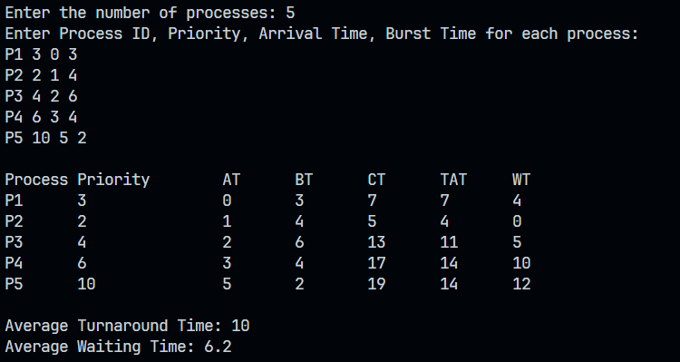

Non Pre-emptive :
#include <bits/stdc++.h>
using namespace std;

int main(){
cout<<"Enter the number of processes: ";
int n; cin>>n;

vector<pair<int, pair<pair<int, int>, string>>> v1(n);

cout << "Enter Process ID, Priority, Arrival Time, Burst Time for each process:\n";
for (int i = 0; i < n; i++) {
string id;
int at, bt, p;
cin>>id>>p>>at>>bt;
v1[i] = {p, {{at, bt}, id}};
}

sort(v1.begin(), v1.end(), [](const auto &a, const auto &b) {
return a.second.first.first < b.second.first.first;
});

vector<int> ct(n), tat(n), wt(n);
int temp = 0;
vector<bool> done(n, false);

for (int comp = 0; comp < n; comp++) {
int j = -1;

for (int i = 0; i < n; i++) {
if (!done[i] && v1[i].second.first.first <= temp) {
if (j == -1 || v1[i].first < v1[j].first) {
j = i;
}
}
}

if (j == -1) {
for (int i = 0; i < n; i++) {
if (!done[i]) {
temp = v1[i].second.first.first;
break;
}
}
comp--;
continue;
}

int at = v1[j].second.first.first;
int bt = v1[j].second.first.second;

temp = max(temp, at) + bt;
ct[j] = temp;
tat[j] = ct[j] - at;
wt[j] = tat[j] - bt;
done[j] = true;
}

cout<<"\nProcess\tPriority\tAT\tBT\tCT\tTAT\tWT\n";
for (int i = 0; i < n; i++) {
cout<<v1[i].second.second<<"\t"<<v1[i].first<<"\t\t"
<<v1[i].second.first.first<<"\t"<<v1[i].second.first.second<<"\t"
<<ct[i]<<"\t"<<tat[i]<<"\t"<<wt[i]<<endl;
}

return 0;
}

Output

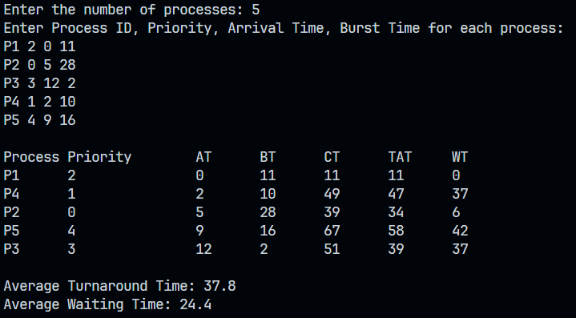

Conclusion :

Preemptive scheduling tends to give better results for processes with varying priorities by reducing waiting times for high-priority tasks. However, non-preemptive scheduling is simpler and can be more efficient in systems where the processes don't need to be interrupted frequently.

Post Lab Descriptive Questions

- Consider a set of processes with their respective arrival and burst times given in milliseconds.

Process | Priority | Arrival Time | Burst Time
P1 | 1 | 0 | 4
P2 | 2 | 0 | 3
P3 | 1 | 6 | 7
P4 | 3 | 11 | 4
P5 | 2 | 12 | 2
- Apply the Priority based CPU scheduling algorithm.
- Draw the Gantt Chart.
- Calculate the Average Turnaround Time.
- Calculate the Average Waiting Time.

Non Pre-emptive

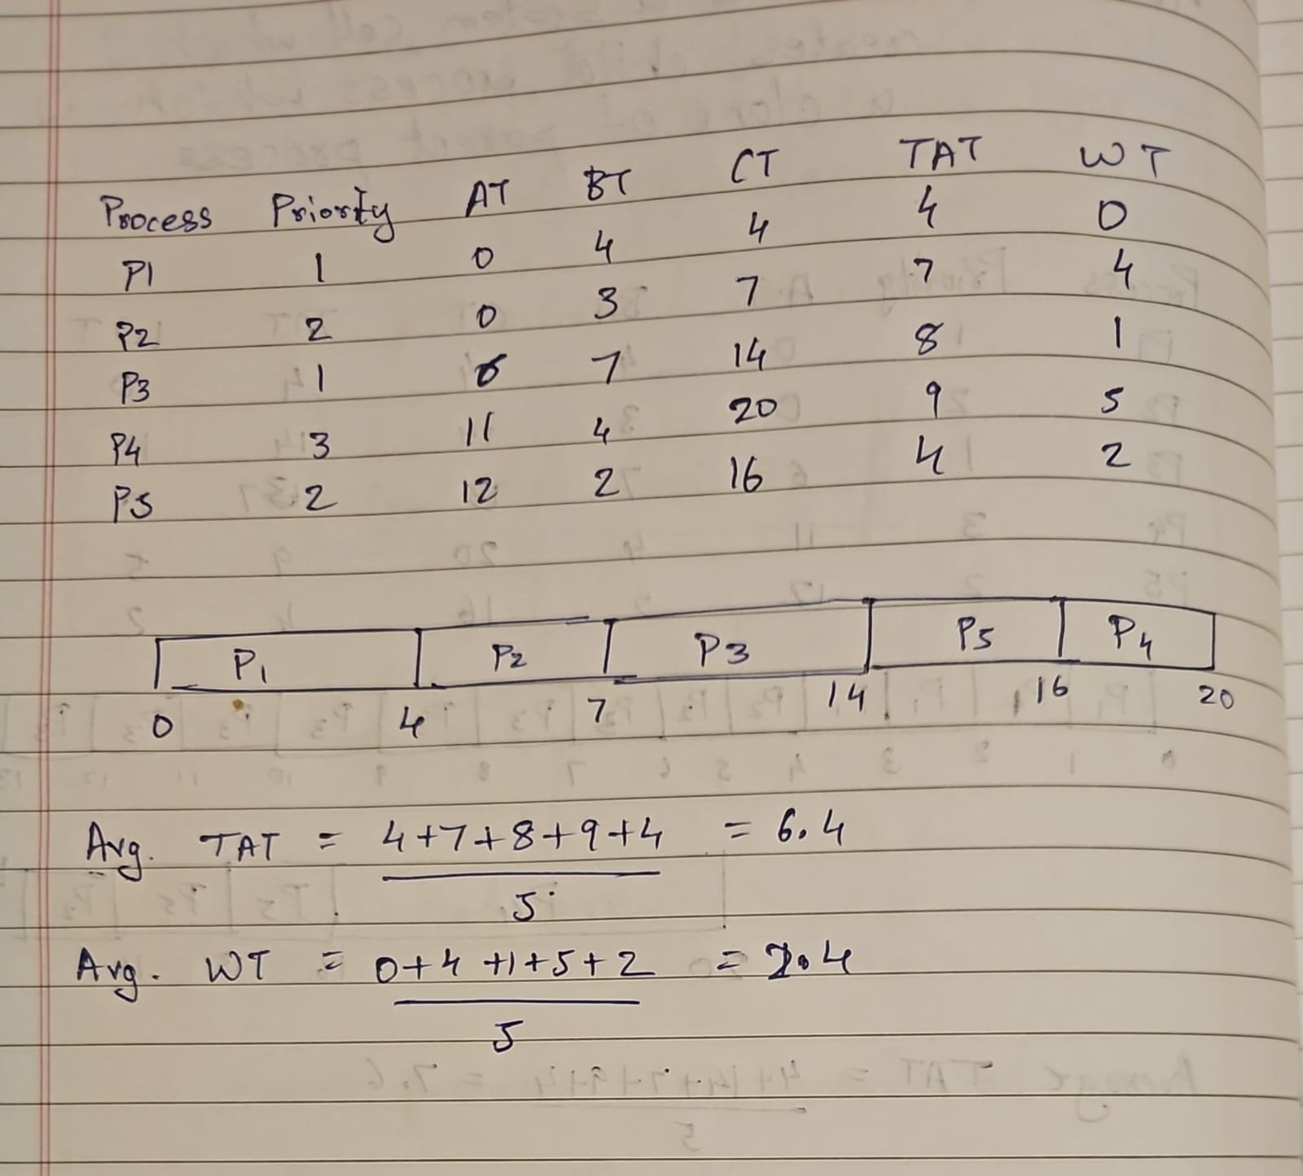

Pre-emptive
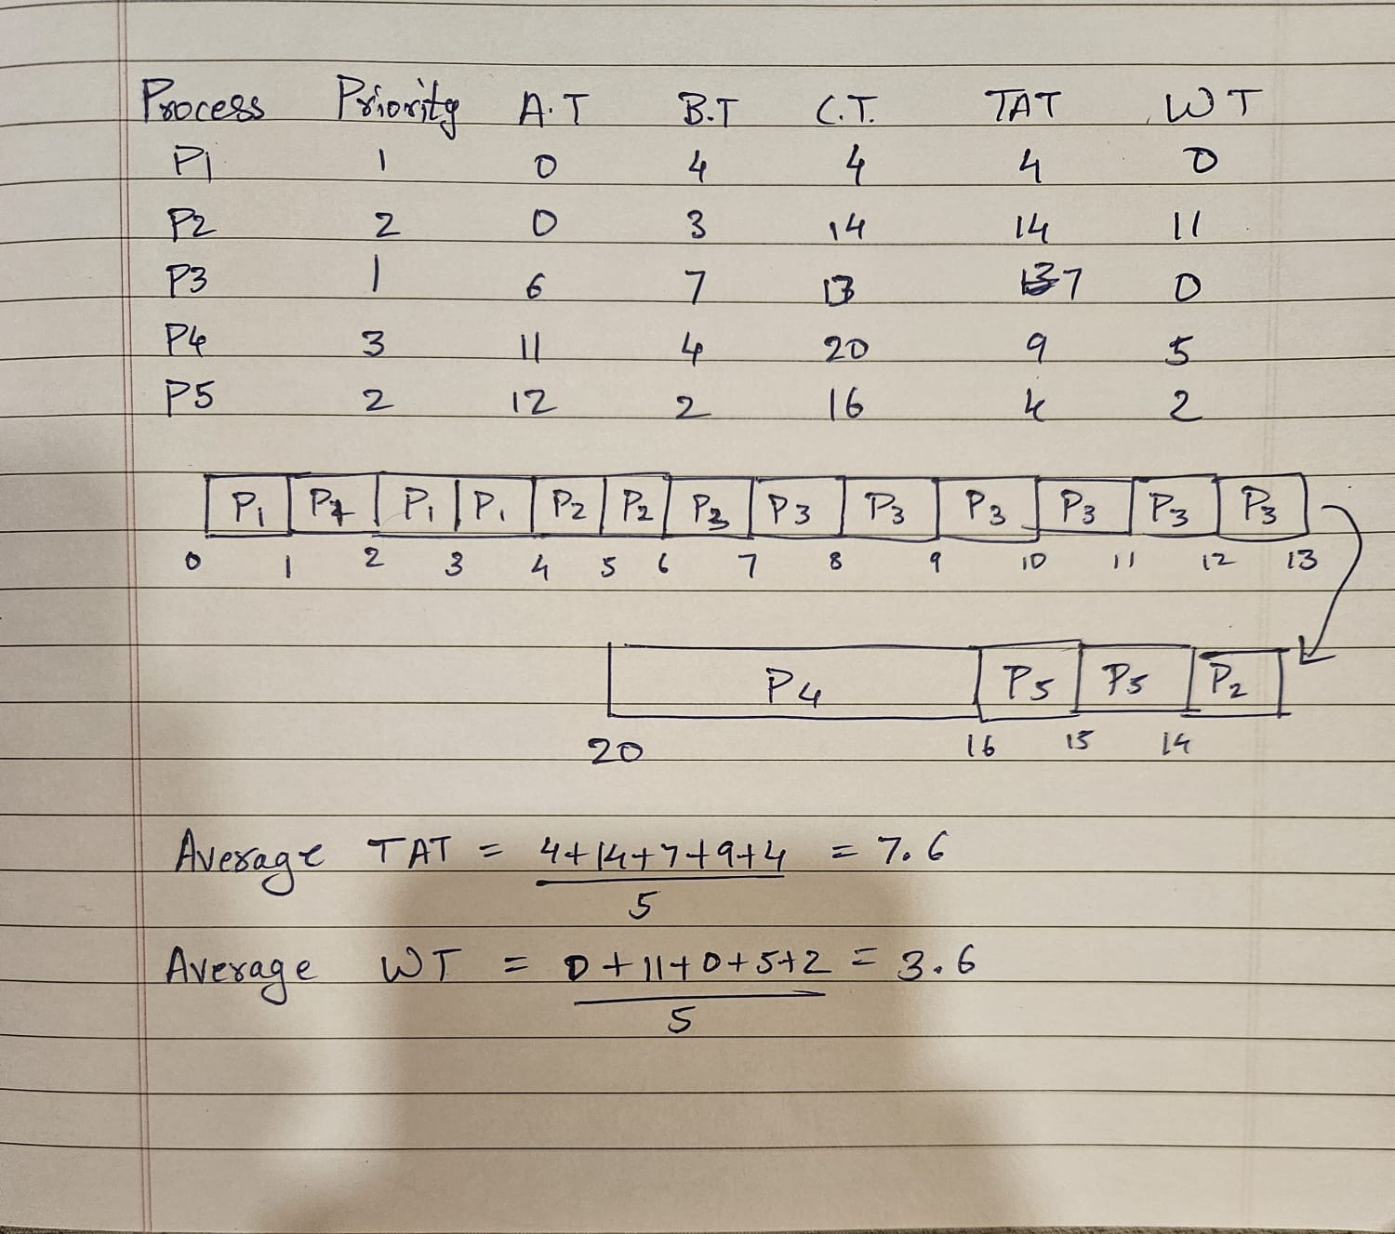

- Analyze the results and comment on the performance of pre-emptive and non pre-emptive for the given process set.

Observations:
- Turnaround Time (TAT):
  - Non-preemptive scheduling gives a lower average turnaround time (6.4) than preemptive scheduling (7.6).
  - This suggests that non-preemptive scheduling allowed processes to complete faster overall.
- Waiting Time (WT):
  - Non-preemptive scheduling resulted in a lower average waiting time (2.4) compared to preemptive scheduling (3.6).
  - The preemptive approach had more context switches, which increased the waiting time.
- Preemptive Priority Effects:
  - In the preemptive approach, processes with higher priority preempt lower-priority ones, leading to frequent context switching.
  - This may have benefited high-priority tasks but caused increased delays for others, leading to a higher overall TAT and WT.
- Non-Preemptive Priority Effects:
  - In the non-preemptive approach, once a process starts executing, it runs to completion.
  - This approach reduces context switches, allowing for better efficiency in some cases.

Conclusion:
- Non-Preemptive Priority Scheduling performed better in terms of average TAT and WT for the given process set.
- Preemptive Priority Scheduling may be useful in scenarios where high-priority tasks need immediate attention, but it introduces additional overhead due to frequent context switching.

Date: 20/03/25 Signature of faculty in-charge

